INTEGRATED FARMING SYSTEM:
Integrated Farming System (IFS) is an interrelated complex matrix of soil, water, plant, animal and environment and their interaction with each other enable the system more viable and profitable over the farming system. Integration of various agricultural enterprises viz., cropping, animal husbandry, fishery, forestry etc. have great potentialities in the agricultural economy. These enterprises not only supplement the income of the farmers but also help in increasing the family labour employment.
- The integrated farming system approach introduces a change in the farming techniques for maximum production in the cropping pattern and takes care of optimal utilization of resources.
- The farm wastes are better recycled for productive purposes in the integrated system.
- A judicious mix of agricultural enterprises like dairy, poultry, piggery, fishery, sericulture etc. suited to the given agro-climatic conditions and socio-economic status of the farmers would bring prosperity in the farming.
Advantages of IFS (Integrated Farming System):
- Higher food production to equate the demand of the exploding population of our nation
- Increased farm income through proper residue recycling and allied component
- Sustainable soil fertility and productivity through organic waste recycling
- Integration of allied activities will result in the availability of nutritious food enriched with protein, carbohydrate, fat, minerals and vitamins
- Regular stable income through the products like egg, milk, mushroom, vegetables, honey and silkworm cocoons from the linked activities in integrated farming
- Inclusion of biogas & agro forestry in integrated farming system will solve the energy crisis
- Cultivation of fodder crops as intercropping and as border cropping will result in the availability of adequate nutritious fodder for animal components like milch cow, goat / sheep, pig and rabbit
- Integrated farming will help in environmental protection through effective recycling of waste from animal activities like piggery, poultry and pigeon rearing
- Firewood and construction wood requirements could be met from the agro forestry system without affecting the natural forest
- Avoidance of soil loss through erosion by agro-forestry and proper cultivation of each part of land by integrated farming
- Generation of regular employment for the farm family members of small and marginal farmers.

COMPONENTS OF IFS:
- Crops, livestock, birds and trees are the major components of any IFS.
- Crop may have subsystem like monocrop, mixed/intercrop, multi-tier crops of cereals, legumes (pulses), oilseeds, forage etc.
- Livestock components may be milch cow, goat, sheep, poultry, bees.
- Tree components may include timber, fuel, fodder and fruit trees.
Factors to be considered
Following factors have to be considered while selecting IFS in rainfed areas.
Soil types, rainfall and its distribution and length of growing season are the major factors that decide the selection of suitable annual crops, trees and livestock components. The needs and resource base of the farmers also decides the selection of IFS components in any farm.
- Suitable grain crops: According to soil type we can select suitable crops.
Black soil:
Cereals: Maize
Millets: Sorghum, bajra
Pulses: Greengram, blackgram, redgram, chickpea, soybean, horse gram
Oilseeds: Sunflower, safflower
FIbre: Cotton
Other crops: Coriander, chillies,
Red soil :
Millets: Sorghum
Minor Millets: ragi, tenai, samai, pani varagu, varagu
Pulses: greengram, red gram, soybean, horse gram, cowpea
Oilseeds: Groundnut, castor, sesame
2. Suitable forage crops
Black soils
Fodder sorghum, fodder bajra, fodder cowpea,Rhodes grass, Elusine sp., Thomson grass
Red soils
Fodder bajra, fodder ragi, fodder cowpea, Muyal Masal (Stylo), siratro, marvel grasses, spear grass, vetiver
3. Suitable tree species
Tamarind, Simarouba, Arappu, Kodai vel, A.tortilis, Maan Kathu vel, A.mellifera, Neem, Hardwickia binata, Ber, Indian Gooseberry, Casuarina, Silk cottonetc. are suitable for red gravelly/sandy red loam soils.
Karu vel, A.tortilis, A.albida, Neem, Vagai, Holoptelia integrifolia, Manja neythi, Hibiscus tilifolia, Gmelina arborea, Casuarina, Subabuland Adina cordifolia are suitable for black soils.
- Suitable livestock and birds
Goat, sheep, white cattle, black cattle, pigeon, rabbit and poultry.
Agronomic approaches for increasing overall productivity and sustainability of IFS
The various agronomic approaches for increasing the overall productivity and
sustainability of IFS:
- Adoption of improved cropping system according to the rainfall and soil moisture availability
- Selection of suitable grain crop species, tree species that supply pods/leaves for a longer period or throughout the year
- The surplus fodder leaves, crop residues etc. during the rainy season should be preserved as silage/hay for lean season (summer).
FARMING SYSTEM IN DIFFERENT AGRO-CLIMATIC ZONES:
- EASTERN HIMALAYAS – Primitive crop husbandry with rice, pulses, millets etc. Agro forestry systems are also common. Piggery and poultry are the chief livestock activity.
- INDO-GANGETIC PLAINS- Intensive crop husbandry like rice-wheat-maize/mustard/pulses and livestock, dairy, cattle and buffaloes.
- CENTRAL AND SOUTHERN HIGHLANDS- Cotton-sorghum-millets/pulses with dairy cattle, sheep and goats and poultry are the secondary livestock and animal husbandry enterprises.
- HIGH ALTITUDES COLD DESERTS- Pastures with forestry, goats, rabbits and agricultural crops like millets, wheat, barley and fodder.
- ARID AND DESERT REGION- Animal husbandry with camels, sheep and goats, and growing with fodder and field crops.
- WESTERN AND CENTRAL HIMALAYAS- Horticultural crops as major components and agriculture mainly on hill terraces and slopes with maize, rice, wheat, pulses and fodder crops.
- WESTERN GHATS- Major activity on plantation crops, cultivating rice and pulses are the secondary agricultural activity. Cattle, sheep and goats are the livestock components which in most parts are maintained as large herds.
- DELTA AND COASTAL PLAINS- Rice cultivation with other enterprises like fishery, poultry and piggery etc.
ENERGY FLOW IN DIFFERENT FARMING SYSTEM:
- CROP-LIVESTOCK-FORESTRY FARMING SYSTEM:
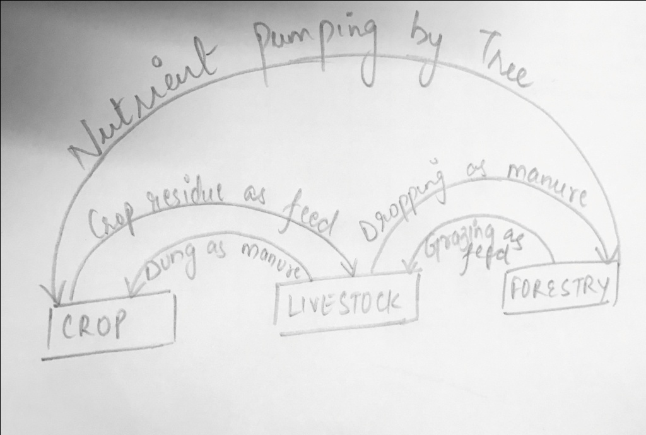
- CROP-FISH-POULTRY FARMING SYSTEM:
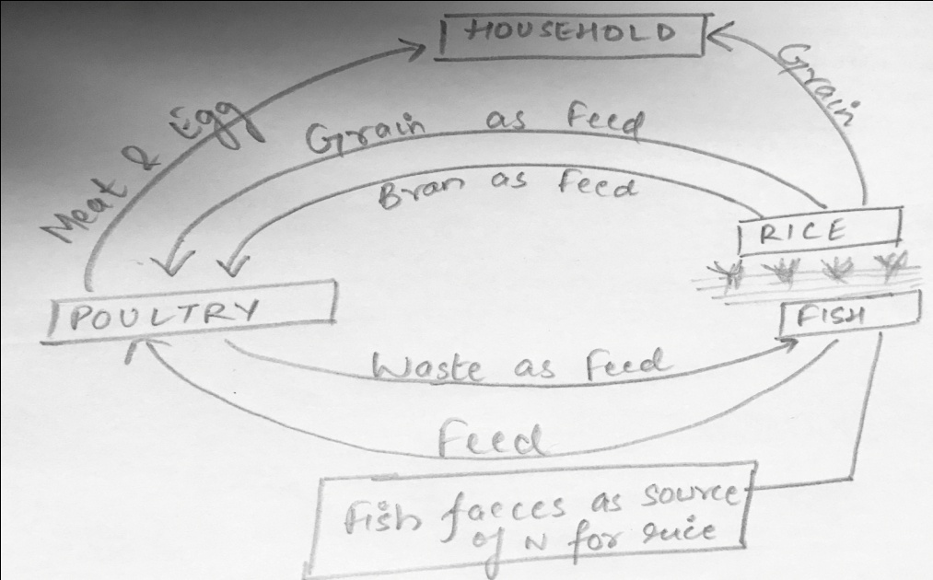
- CROP-LIVESTOCK-POULTRY-FISHERY FARMING SYSTEM:
